

Non-Contact Type Clinical Thermometer for Adult People Design Description

PartNumber:24-06-TRM-000
Rev: 01
Date: 20 Nov 2024

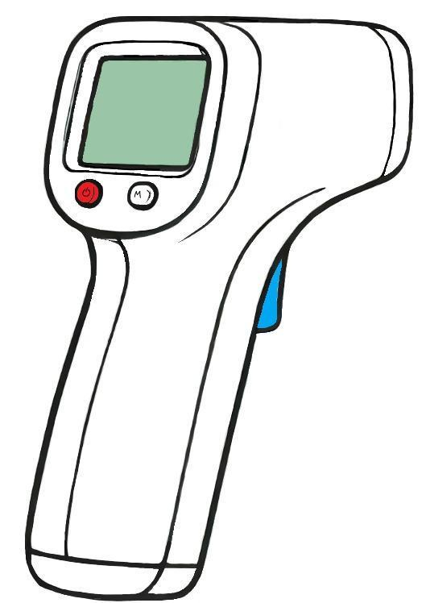

ALL RIGHTS RESERVED. REPRODUCTION OR ISSUE TO THIRD PARTIES IN ANY FORM WHATEVER IS NOT PERMITTED WITHOUT WRITTEN AUTHORITY FROM THE PROPRIETORS.
CHANGE RECORDS


FIRST RELEASE

CREATED BY

Name Title Date Sign.

Beyza YAŞAR Electric Eng 20.11.2024

CHECKED BY
Name Title Date Sign.

Doğa ERPAK Quality Eng 21.11.2024 08.10.2024

APPROVED BY
Name Title Date Sign.

Elif AĞILLAR Program Mng 21.11.2024

REVISIONS
Rev. No Change Description Date QA Approval
01 Block shematic 04.12.2024 Approved
02 Block shematic 19.12.2024 Approved

TABLE OF CONTENTS

ATTACHMENT-3 1
CHANGE RECORDS 2
FIRST RELEASE 2
REVISIONS 2
- SCOPE 4
- DESCRIPTION 4
- REFERENCES 4
- SYSTEM ARCHITECTURE 5
  - PHYSICAL (BLOCK SCHEMATICS) 5
  - FUNCTIONAL (OPERATION) 6
  - PRINCIPLE OF OPERATION 6
- CONFIGURATION ITEMS 8
- SCOPE

The body temperature of the patient is a crucial vital sign for evaluating overall health, often assessed in conjunction with blood pressure and pulse rate. Various temperatures are recorded at distinct reference body sites, reflecting the equilibrium between heat production, transfer, and loss.
In this context, a non-contact thermometer designed specifically for adults is used to measure body temperature. This thermometer is held remotely to the forehead and provides accurate measurements necessary for monitoring health status.

- DESCRIPTION

The thermometer will measure skin temperature by zooming the sensor to the forehead area. It shall have a graphical display showing the body temperature (OLED Display (128x64 I2C)) with characters of sufficient size for easy reading, making the measurement mode in the unit of measurement of your choice (°F, °C, K). The battery will be rechargeable and will be powered by the necessary peripherals to make it ready for immediate measurement. A microcontroller (Arduino Pro Mini or ATmega328P MCU) will be used in the thermometer for the ability to process temperature data, control sensor inputs, and facilitate the user interface, providing precise and efficient temperature monitoring and management. It is preferred that the firmware be easily updated when required.

- REFERENCES

  - 24-06-TRM-801: System Requirement Specification
  - ISO 80601-2-56:2017: Particular requirements for basic safety and essential performance of clinical thermometers for body temperature measurement
  - IEC 60601–1:2005+A1:2012: Medical electrical equipment - Part 1: General requirements for basic safety and essential performance
  - IEC 60601‐1‐2:2014: Medical electrical equipment — Part 1-2: General requirements for basic safety and essential performance — Collateral Standard: Electromagnetic disturbances Requirements and tests
- SYSTEM ARCHITECTURE

  - . PHYSICAL ( BLOCK SCHEMATICS)

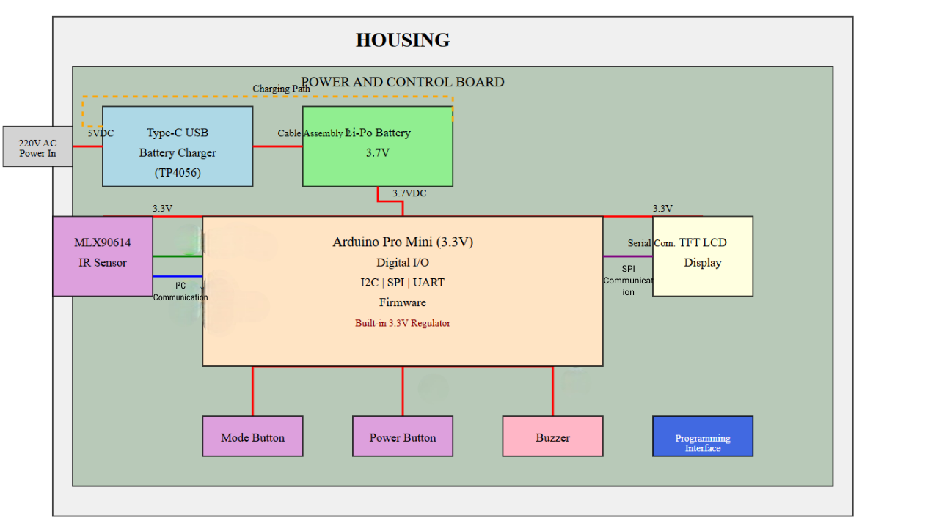
Figure 1. Block Schematics of The Design
  - . FUNCTIONAL (OPERATION)

- Since the device is battery-powered, it can be monitored by the battery indicator on the screen.
- To start the device, the on/off button is pressed.
- Once operational, the temperature is sensed by the sensor, amplified, processed, digitized and sent to the MCU for further processing.
- The temperature is calculated by the MCU and displayed on the digital display.
- The buzzer will emit a sound when the measurement is complete.

  - . PRINCIPLE OF OPERATION

- The non-contact type thermometer designed for adults will measure body temperature from the forehead area. In this system designed for adults, the forehead area has been selected considering easy applicability and hygiene conditions.

- MLX90614 sensor will be used as an infrared sensor in the thermometer. It was chosen for its high sensitivity, linearity and long life.

- 1. Infrared Temperature Sensor:
- - MLX90614 infrared temperature sensor is used.
- - These sensors detect the surface temperature of the object to be measured through infrared radiation.
- - An analog temperature signal is obtained from the sensor.

- 2. Analog to Digital Converter (ADC):
- - The analog temperature signal from the sensor is converted into a digital signal by the ADC module on the Arduino Nano/ATmega328P.
- - This allows the microcontroller to process the temperature data.

- 3. Microcontroller (Arduino Nano/ATmega328P):
- - Receives the digital temperature data from the ADC module.
- - Calculates the temperature value in Celsius, Fahrenheit, or Kelvin.
- - Stores the last 3 measurement values on EEPROM.
- - Checks the temperature threshold value and alarms with a buzzer if necessary.
- - Performs battery level control.

- 4. Display Unit (OLED Display):
- - It displays the temperature value calculated by the microcontroller on a 128x64 OLED display.
- - The display also provides mode selection (Celsius/Fahrenheit) and battery status indication.

- 5. Power Management:

- 3.7V battery charging is provided from 5V input using TP4056 module
- 3.3V voltage regulator distributes power to all circuit elements
- Battery charge level indication
- Battery protection circuits
- - Sleep mode is implemented for low power consumption.

- 6. User Interface:
- - Button for mode selection (Celsius/Fahrenheit)
- - Button for on/off
- - Buzzer to alert the user when the temperature measurement is complete

- 7. Case and PCB Design:
- - Ergonomic and compact case design
- - Window for sensor
- - Ease of battery and charging access
- - PCB design with EMI/EMC measures
- - Sensor position optimization

- Thus, a user-friendly thermometer system that does not require contact and can measure temperature with the infrared method is created. This working principle, which I have detailed according to software requirements and important features, will help the successful realization of the project.

- CONFIGURATION ITEMS

- Sensor Assembly / 24-06-TRM-20
- MLX90614 Infrared Temperature Sensor

- Power and Control Board Assembly /24-06-TRM-21
- Arduino Pro mini /24-06-TRM-003
- 0.96-inch TFT-LCD Display Kit /24-06-TRM-009
- TP4056 Li-ion Battery Charging Module /24-06-TRM-002
- Firmware /24-06-TRM-400
- Power and Control PCB /24-06-TRM-12
- On/Off Button
- Mode Selection Button

- Housing /24-06-TRM-200
- Case /24-06-TRM-201
- Battery Compartment /24-06-TRM-202
- Lipo Battery /24-06-TRM-001

